The BIG Gospel Sing-Along
St Saviour’s Parish Church
Westgate-on-Sea, CT8 8NX
FREE ENTRY

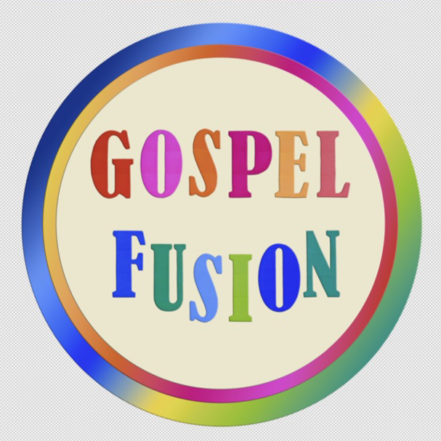

Come and join the Gospel Fusion singers and rock-band for a fun filled sing-your-heart-out afternoon


Suitable for all ages; invite your family, friends and neighbours!
Includes an interval with Refreshments

21st June 2026 at 3pm

Bookings must be made in advance by emailing: office@stsaviourswestgate.org.uk

