
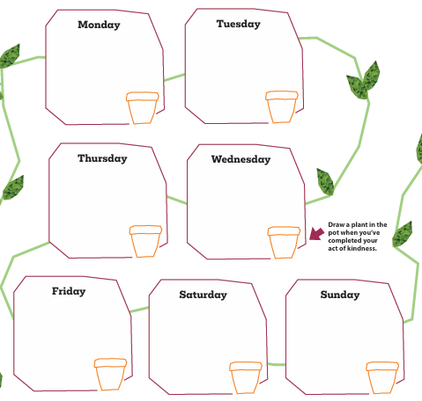
Some ideas – adults and children:
Offer someone a lift.
Sit with someone who looks lonely.
Tidy up – without being asked.
Bake a cake and give it away.
Share your snack.
Smile and say hello.
Take out and return the bins.
Give away a book (or a toy) you really enjoy.
Pick up litter.
Set the table or clear up after a meal.



