Join us for a
Candlelit Trinity Taize Service
at St John the Baptist, Stoke-by-Clare
on Sunday 31st May 2026 at 7.00pm
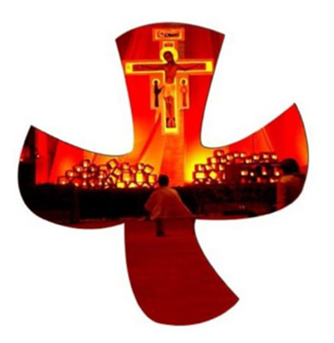
Taize is a tranquil form of worship with music, silence and time for reflection.

Everyone is warmly invited

The Chedburgh Taize Ensemble will be leading the music.
If any local singers would like to join them, there will be a short practice beforehand to run through any chants that are unfamiliar.

