
Your Bible is not just for Sunday
The Gospels - Mark
Sunday  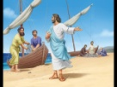  Mark 1-2  Baptism, Temptation  Calling of Disciples | Monday    Mark 3-5  Parables & Miracles | Tuesday  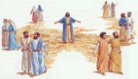  Mark 6-7  Sending Out  A woman of Faith | Wednesday  hin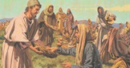  Mark 8-10  Miracles, Healing  Teaching | Thursday  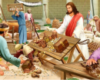  Mark 11-12  Cleansing the Temple  Love | Friday    Mark 13-14  Leave Her Alone | Saturday  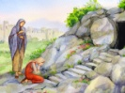  Mark 15-16  Death and Resurrection
Every day is a Bible day
Spend time each day with God.

