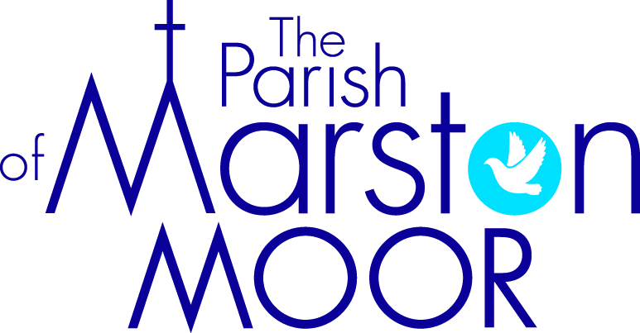 | Askham Richard | Bilbrough | Long  Marston | Rufforth | Tockwith
3rd  5th Sunday of Easter |  | 9.00am  Holy Communion | 8.30am  Breakfast Praise | 11.00am  Holy Communion | 11.00am  Refresh Service
10th  6th Sunday of Easter | 9.00am  Holy Communion | 10.00am  Parish Praise | 5.00pm Holy Communion | 11.00am  Worship Together | 11.00am  Holy Communion
17th  7th Sunday of Easter | 10.00am  Pet blessing service | 10.00am  Holy Communion | 11.00am  Pet blessing service | 11.00am  All Age Worship | 6.00pm  BCP Evensong
24th  Pentecost | 9.00am  Holy Communion | 10.00am  Family Praise | 11.00am  All Age Worship | 11.00am  Holy Communion | 11.00am  Informal Parish Praise
31st  Trinity Sunday | Parish Holy Communion  St. Mary’s Church, Askham Richard 10.00am

