Bible Studies
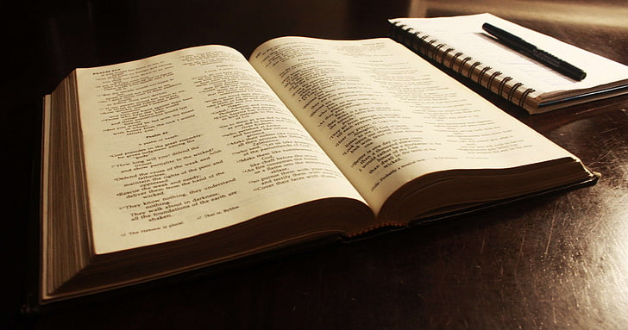
We are holding our next 3 monthly bible study/discussion group on,
Monday 27th April 2026, 2pm to 4pm
Monday 25th May 2026, 2pm to 4pm
Monday 29th June 2026, 2pm to 4pm
In Dufton Village Hall, Community Room
We are currently looking at the Seven Signs of John. It doesn’t matter if you can only come to one or two, everyone is welcome of any faith or none.

