!
Your Bible is not just for Sunday
He is Risen!
Sunday  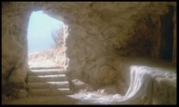  Luke 24:1-12  Empty Tomb | Monday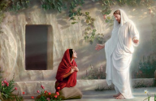  John 20:10-18  He is Risen! | Tuesday    Luke 24:13-35  The Emmaus Road | Wednesday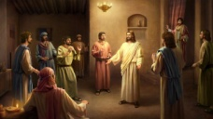  John 20:19-23  The Locked Room | Thursday  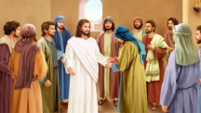  John 20:24-29  Thomas | Friday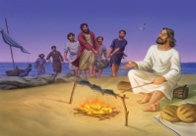  John 21:1-14  A Miraculous Catch | Saturday  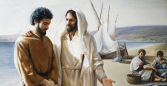  John 21:15-25  Feed My Sheep
Every day is a Bible day
Spend time each day with God.

