
Your Bible is not just for Sunday
The Gospels ~ Matthew
Sunday  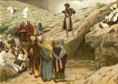  Matthew 1- 4  Birth of Christ  Prepare the Way | Monday  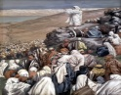  Matthew 5-7  The Beatitudes  How to Live | Tuesday  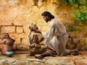  Matthew 8-12  Miracles  Are You the One? | Wednesday  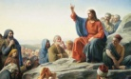  Matthew 13-16  Parables and Healing | Thursday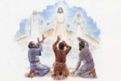  Matthew 17-20  Transfiguration,  Healing & Teaching | Friday  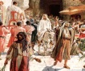  Matthew 21-25  Triumphal Entry  Parables & Teaching | Saturday    Matthew 26-28  The Last Supper  The Final Week
Every day is a Bible day
Spend time each day with God.

