Wincanton Parish Church
Coffee Morning and Plant Sale!

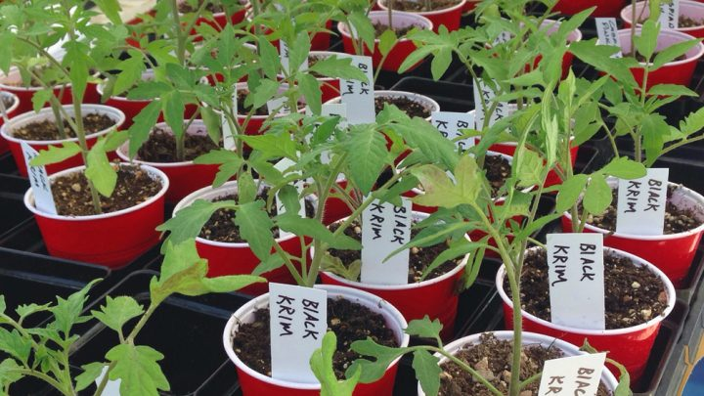


In the Parish Church

Saturday 9th May

10:00am – 12:00 noon

PLANTS! Refreshments

Homemade Cakes

Book Stall & Raffle!

ALL WELCOME!

