Being With Course
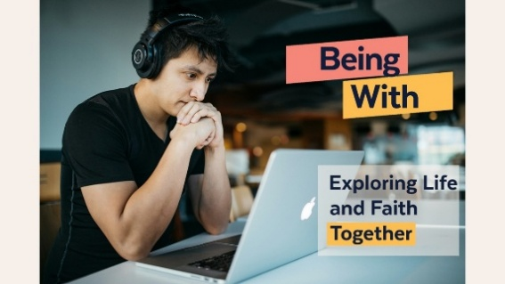

Online Course begins
Wednesday 28th January 2026
8.00pm – 9.30pm
Every Wednesday for 10 weeks
Zoom link provided

Being With: An online gentle exploration of faith starting 28th Jan 8-9:30pm.
(Limited number of places. If it’s full email me to find out when the next one starts.) https://www.eventbrite.co.uk/e/being-with-tickets-
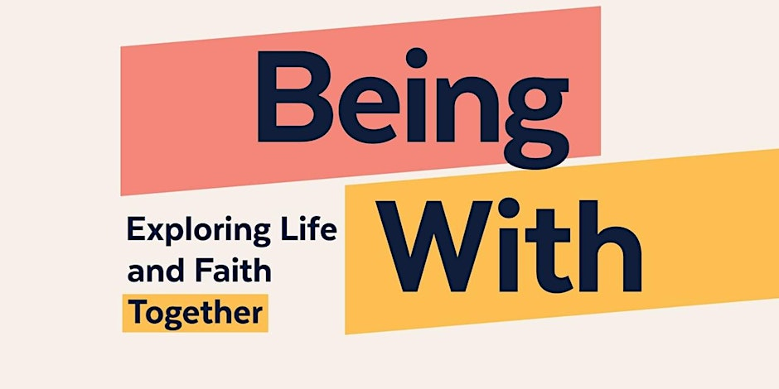

No previous experience or knowledge necessary – just an openness to listening and reflecting.

Being With: An in person group meeting
every other Sunday at the Vicarage
19 Station Road, Irchester NN29 7EH
from 25th Jan 7.30-9:00pm.
Call Revd Debbie on 01933 312674 to reserve your place.

