Benefice of Egremont with Bigrigg & Haile
St Mary and St Michael’s Church
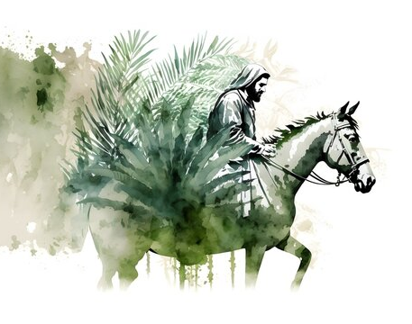PP

Join us on Sunday 29th March at 10:00
With
Egremont Town Band
All Welcome
Palm Sunday

H

