Reading
2 Corinthians 1: 3-7; Luke 2: 33-35
Today’s service
Revd Maggie Crosbie will be leading our Family Communion service as we celebrate Mothering Sunday. Posies will be distributed to all ladies during the service and refreshments will be served after the service including Peter’s simnel cake.

Next Sunday
Revd Tony Rogerson will be presiding and preaching at our service of Holy Communion at 10.00 am.
Lent Study Group
The 4th of our Lent study courses will be held next Wednesday in church starting at 7.15 pm with refreshments served from 7.00 pm. We will finish by 8.30 pm. Over 6 weeks we invite you to 'Come and See" as we look to dig deeper into our faith through looking at one of the core celebrations of the church, the Eucharist. We will examine it from a Biblical and theological perspective as a means of building our faith and growing our relationship with Jesus. Everyone is welcome and you do not need to attend every session.
Electoral Roll
In advance of our Annual Parochial Church Council meeting, we will be updating our electoral roll in the next 2 weeks. If anyone would like to join the electoral roll, then please speak to Mike who can provide a form.

St Peter’s Church Wootton

Sunday 15th March

Mothering Sunday

All Age Family Communion
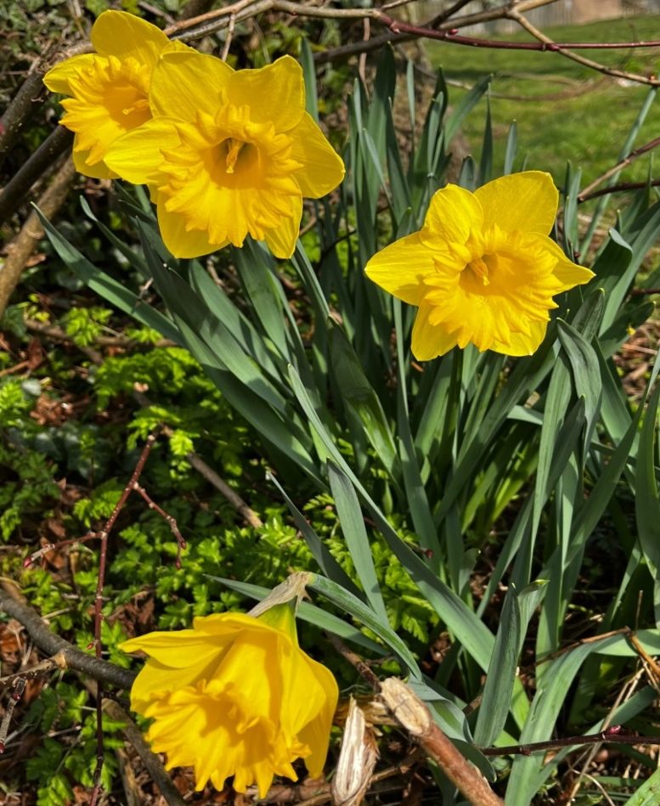

St Peter’s Wootton
A vibrant, growing church
at the heart of the community
spreading the love, joy and peace of Jesus to all

Lent Lunches
We hope that members of our congregation will once again offer Lunches during Lent in support of a local charity. The PCC have agreed that all monies raised will be passed to the Abingdon Food Bank and the Abingdon Bridge, a local charity that provides guidance and support for young people age 13 to 25. If anyone would like to host a Lent lunch, just find a date, put a sheet at the back of the church and invite friends and neighbours. Shirley and Peter will be hosting a lent lunch on Saturday 21st March. Please sign the sheet at the back of the church if you would like to come.
Remembering Loved Ones at Easter
If anyone would like to contribute towards Easter flowers in memory of loved ones please can you pass on the name or names and any donation to Sally or Mike. Many thanks.
Thanksgiving Service for Joyce Leadley
A Thanksgiving service for Joyce will be held on Thursday 19th March at 2.00 pm at St Peter’s Church. Everyone is welcome. If anyone has any memories of Joyce that can be shared during the service, please speak to Maggie, Mike or Shirley. A memorial page has been set up for Joyce for people to share memories or photos and can be found at: joyceleadley.muchloved.com

Funeral Service for Allen Perkins
The funeral service for Allen Perkins, who passed away on 21st February, will be held on Wednesday 8th April at 1.00 pm at South Oxford crem. Everyone is welcome.

FUTURE SERVICES

Wednesday 18th March – Holy Communion at 10.00 am
Sunday 22nd March – Holy Communion at 10.00 am – Revd Tony Rogerson.
Sunday 29th March – Holy Communion at 10.00 am as we celebrate Palm Sunday – Revd Maggie Crosbie. Note: for those that are able we will be meeting at the Community Centre at 9.45am and processing to church led by a donkey.
Monday 30th, Tuesday 31st March – A Service of Compline at 7.30 pm
Wednesday 1st April – Holy Communion at 10.00 am
Wednesday 1st April – A Service of Compline at 8.30 pm
Thursday 2nd April (Maundy Thursday) – Holy Communion at 7.30 pm
Friday 3rd April – An Hour at the Cross 2.00 pm -3.00 pm
Sunday 5th April (Easter Day) – Family Communion at 10.00 am followed by Easter Egg hunt and refreshments – Revd Stephen Coe
Our next Open Church is on Saturday 28th March between 10.00 and 12.00 - do drop in for a bacon roll, tea, coffee and biscuits and the opportunity for a friendly chat surrounded by the peace and beauty of our ancient church.
Further details are available at www.woottonchurch.co.uk
You can contact us by email at: woottonvicarage@btinternet.com
or by telephone on 01865 735661. Maggie can be contacted directly at: revmaggiecrosbie@gmail.com
Collect for Mothering Sunday
God of compassion,
whose Son Jesus Christ, the child of Mary,
shared the life of a home in Nazareth,
and on the cross drew the whole human family to himself:
strengthen us in our daily living
that in joy and sorrow
we may know the power of your presence
to bind together and to heal;
through Jesus Christ your Son our Lord,
who is alive and reigns with you,
in the unity of the Holy Spirit,
one God, now and for ever. Amen.

Blessing of flowers
Loving God of all compassion and comfort
we thank you for all the love we have known in our homes,
among our friends, with God’s people.
Bless these flowers and, as we share them,
may they remind us to be people of thanks,
people of love, and people of joy in Jesus’ name.
All Amen

