St Peter & St Paul’s Church


EASTER DAY

Family Communion Service
and
Easter Egg Hunt

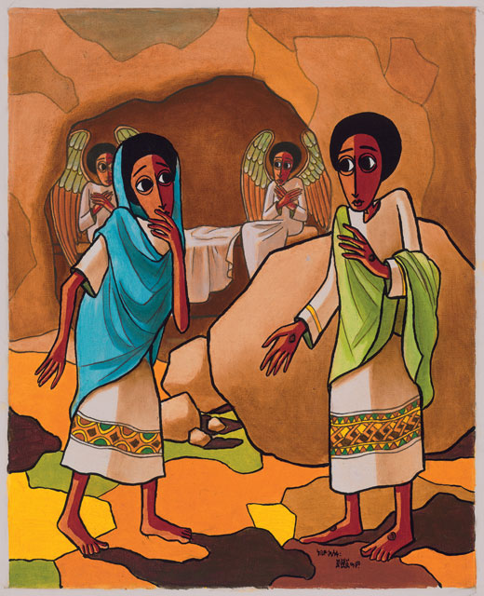

Sunday 5th April
10:00am

Everybody Welcome!

