On Friday 26th June at 7.30pm
at Sefton Church L29 7WG
An evening of fun entertainment by:
M A D Ukes
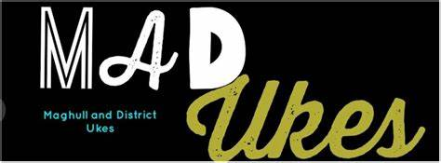
ADMISSION - £8.00 Adults; £4.00 under 14yrs
Including a Burger from the BBQ.
Vegetarian option is available if pre-booked.
Please bring your own drinks.
Doors Open at 6.45pm. There will be a Raffle
Tickets are available from April in Church on a Sunday or Monday morning and at our Easter Bank Holiday Open Afternoon or reserved by ringing 07977344169.
Please note: Entrance is by ticket only – last date for sales is Friday 19th June.
All money raised goes to our Church Funds.

