The Parish of
St.Bartholomew,
Westhoughton
St George’s Church
Palm Sunday
Sunday 29th March 9:15am
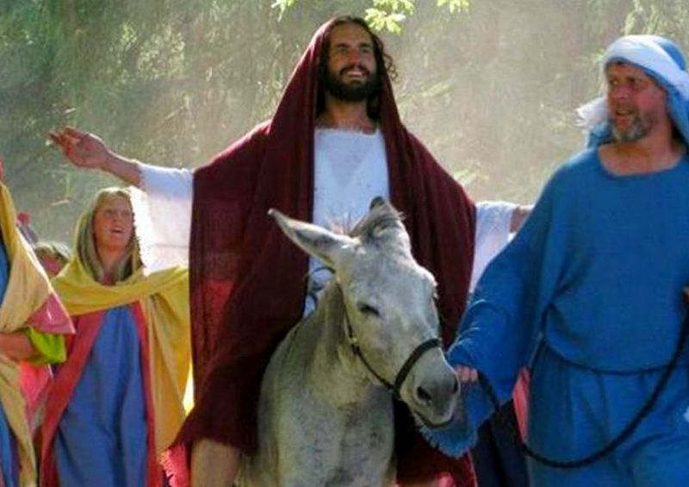
Café Church
Palm Crosses
Activities for all
Refreshments
We remember the entry of Jesus into Jerusalem at the start of Holy Week.
All Welcome

