May the peace of God, which passes all understanding, keep your hearts and minds in the knowledge and love of God, and may this blessed time of Easter bring comfort to those in grief and hope to us all.

Do you have questions? Want to join our mailing list?
Please contact Anthony Buckley (vicar@smng.org.uk).
Other enquiries: office@smng.org.uk

Online events are available on our channel: www.youtube.com/c/StMichaelattheNorthGateChurchOxford

You can also find us on social media:


Twitter (@smng_oxford),
Instagram (@st.michael_at_the_north_gate)
Facebook (@SMNG.Oxford)

St Michael at the North Gate, Cornmarket Street
Oxford OX1 3EY
www.smng.org.uk

Lent and Easter 2026

At St Michael at the North Gate Church
The City Church of Oxford


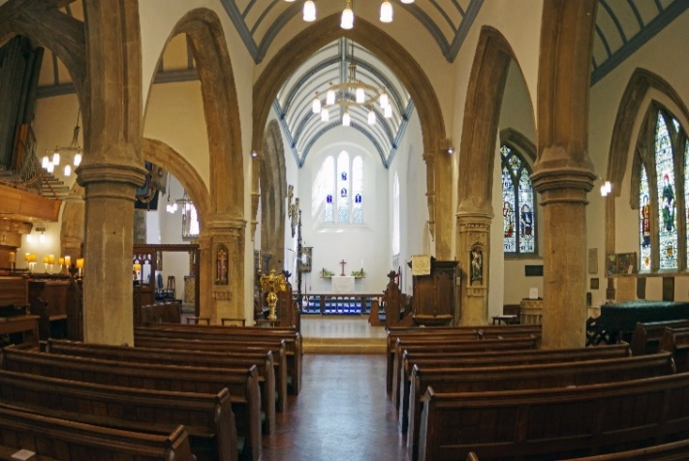

LENT

Wednesdays 18th and 25th March
5.45pm to 6.45pm Lent Course on Christian Poets (after Compline)
We will discuss Betjeman on 18th and The Seafarer (anonymous Old English Poem) the 25th.


DURING HOLY WEEK

Palm Sunday – 29th March

8.00am – 8.30am Holy Communion

10.30am – 11.30am Palm Sunday Mattins
with Procession

Monday – 30th March
9.00am to 9.15am Morning Prayer

5.30pm to 5.45pm Evening Prayer

Tuesday – 31st March

9.00am to 9.15am Morning Prayer

5.30pm to 5.45pm Evening Prayer

Wednesday – 1st April

9.00am to 9.15am Morning Prayer

1.00pm to 1.30pm Holy Communion

5.30pm to 5.45pm Compline


Maundy Thursday – 2nd April

9.00am to 9.15am Morning Prayer

3.00pm Children’s Church Service (Parish Room)


7.30 – 8.30pm Holy Communion

Good Friday – 3rd April

9.00am to 9.30am Morning Prayer for Good Friday

1.00pm – 2.00pm At the foot of the cross

5.30pm – 6.00pm Evening reflection

Holy Saturday – 4th April

12 noon and 2.30pm Passion Play, New Road Baptist Church
6pm to 6.30pm A service for Easter Even


Easter Sunday – 5th April
8.00am – 8.30am Easter Day Communion

10.30am – 11.30am Easter Day Communion

