Holy Week and Easter - Kelsall Churches


Palm Sunday 29th March - Blessing of Palms
9.00am Holy Communion (said) St Philips
10.30am Holy Communion with hymns St Philips


Maundy Thursday 2nd April
7.00 pm at Kelsall Methodist Church
Join us in a simple supper and breaking of bread, as we recall the events of the Last Supper.

Good Friday 3rd April
Meet at Kelsall Methodist Church
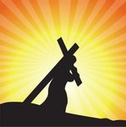
10.30am for Walk of Witness to St Philips
11.00am The Way of the Cross
readings, prayers and hymns
4.00pm in St Philips
Stainers Crucifixion led by Joint Churches Choir

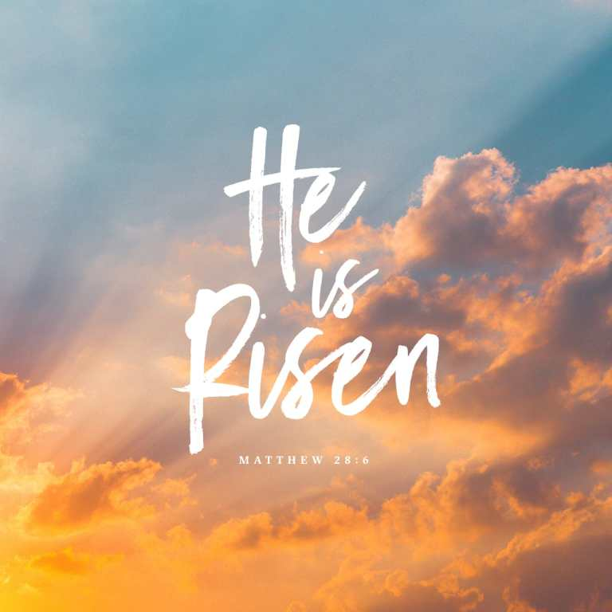
EASTER Sunday 5th April

9.00am Easter (Said) Holy Communion St Philips

10.30 am at Kelsall Methodist Church
We join together to celebrate
Family Easter Holy Communion Service
Followed by refreshments

