

at St Wilfrid’s Church, Egginton, DE65 6HP Sun 15th March

Treat your Mum! 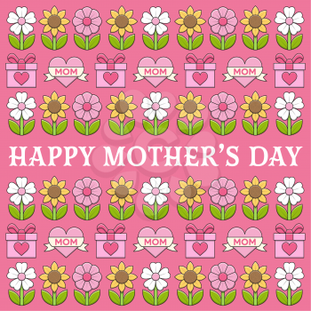
Continental breakfast at 9am or 10am – your choice
Book in to choose Mum’s favourite continental breakfast
rachelc@graceproject.org.uk or 07752 686000

Short celebration to honour our Mothers 9:30-10am during which children can make and fill a trinket box gift for Mum.

