Hunting for Treasure Event

Trendlewood Church at Golden Valley School
Thursday 19 February 10.00am-12.00noon


Free craft activities and refreshments for children and their parents and carers

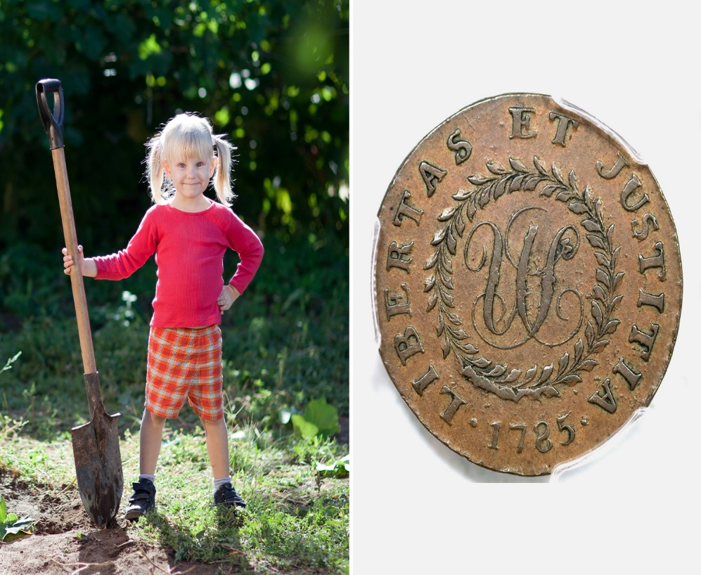
Scan QR code to book places




