Ash Wednesday
18th February
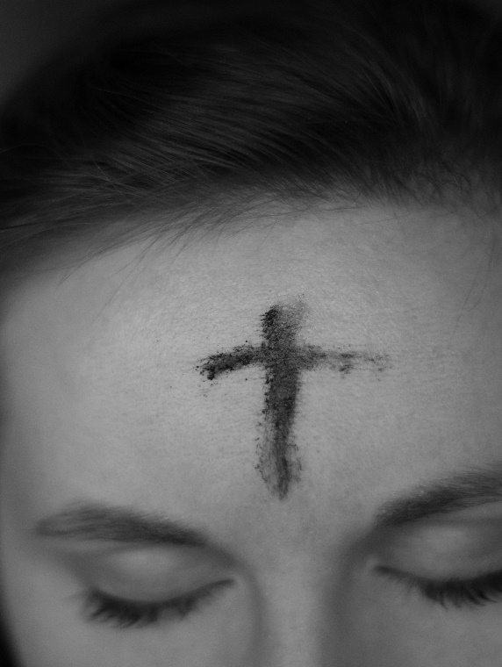
To mark the beginning of Lent we have two special services at Bridlington Priory of Holy Communion, that will also include, for those who would like to receive it, the marking of a cross upon your forehead, using the ash of last year’s burnt palm crosses.
These special services are on Wednesday 18th February at 10am and at 7pm.
All are welcome.

