
Your Bible is not just for Sunday
Joy
Sunday    1 Samuel 18:6  With Joy and Instruments | Monday  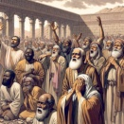  Ezra3:12-13  Noise of Joy and Weeping | Tuesday  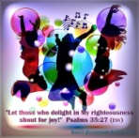  Psalm 35:27  Let Them Shout For Joy | Wednesday    Isaiah 52:7-9  Together They Shout For Joy | Thursday    Luke1:44  My Babe Leaped With Joy | Friday    Matthew 2:10  They Rejoiced! | Saturday    Romans 15:13  A Blessing
Every day is a Bible day
Spend time each day with God.

