St Stephen’s Fradley
Sunday 1st March

9am Holy Communion
(BCP- Traditional)
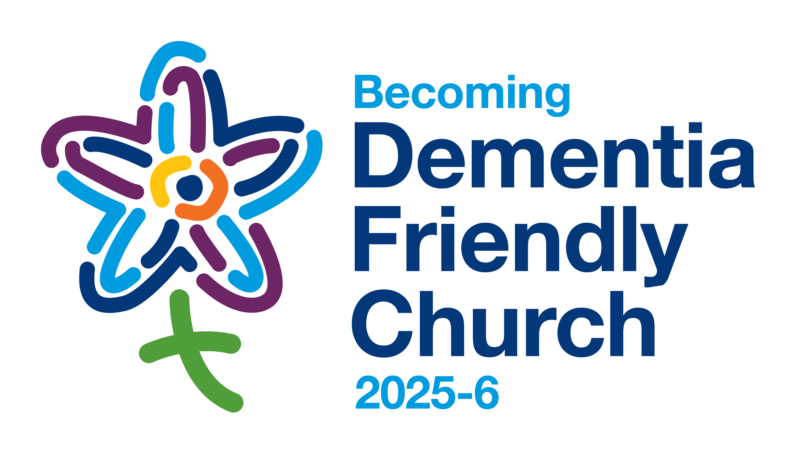
10.30am
Join us for our special
Dementia Friendly Service
with The Music Group
Hymns, Music, Readings, Refreshments

