St. Stephen’s Church
Fradley

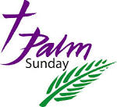
29th March
10.30am
Family Communion
and distribution of Palm Crosses

