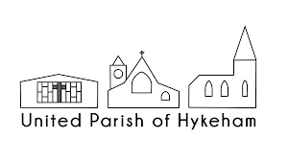
SUNDAY MARCH 29TH (PALM SUNDAY)
ALL SAINTS
09:45 UNITED BENEFICE HOLY COMMUNION
MONDAY MARCH 30TH (MONDAY IN HOLY WEEK)
ST MICHAELS
19:00 EASTER REFLECTION
TUESDAY MARCH 31ST (TUESDAY IN HOLY WEEK)
ST HUGHS
19:00 EASTER REFLECTION
WEDNESDAY 1ST APRIL (WEDNESDAY IN HOLY WEEK)
ST MICHAELS
19:00 REFLECTION
THURSDAY 2ND APRIL (MAUNDY THURSDAY)
ST HUGHS
19:00 PASSOVER SUPPER AND EUCHARIST PLUS VIGIL AND STRIPPING THE ALTAR
FRIDAY 3RD APRIL (GOOD FRIDAY)
THE ARK
10:00 TO 11:30 MESSY CHURCH
ALL SAINTS
14:00 AN HOUR AT THE CROSS
THE GREEN
15:00 EUCEMENICAL SERVICE ON THE GREEN
SUNDAY 5TH APRIL (EASTER DAY)
THE GREEN
06:00 DAWN SEVICE ON THE GREEN
THE ARK
EASTER BREAKFAST (AFTER THE CONCLUSION OF THE 0600 SERVICE)
ALL SAINTS
09:45 HOLY COMMUNION
ST HUGHS
09:45 HOLY COMMUNION

