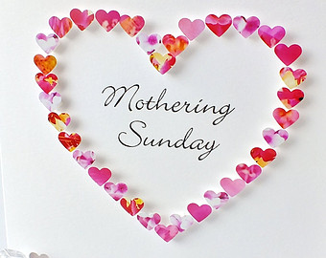


MOTHERING SUNDAY SPECIAL
With CHAMPAGNE/SOFT DRINKS, FLOWERS & CHOCS.
* With music and poetry composed by women.
*Sunflower planting activity & crafts for children.
* To celebrate the role of mums or those who care, like a mum, for others.
ALL WELCOME
9.30am-10.15am
Sunday 15 March

WRESSLE CHURCH

