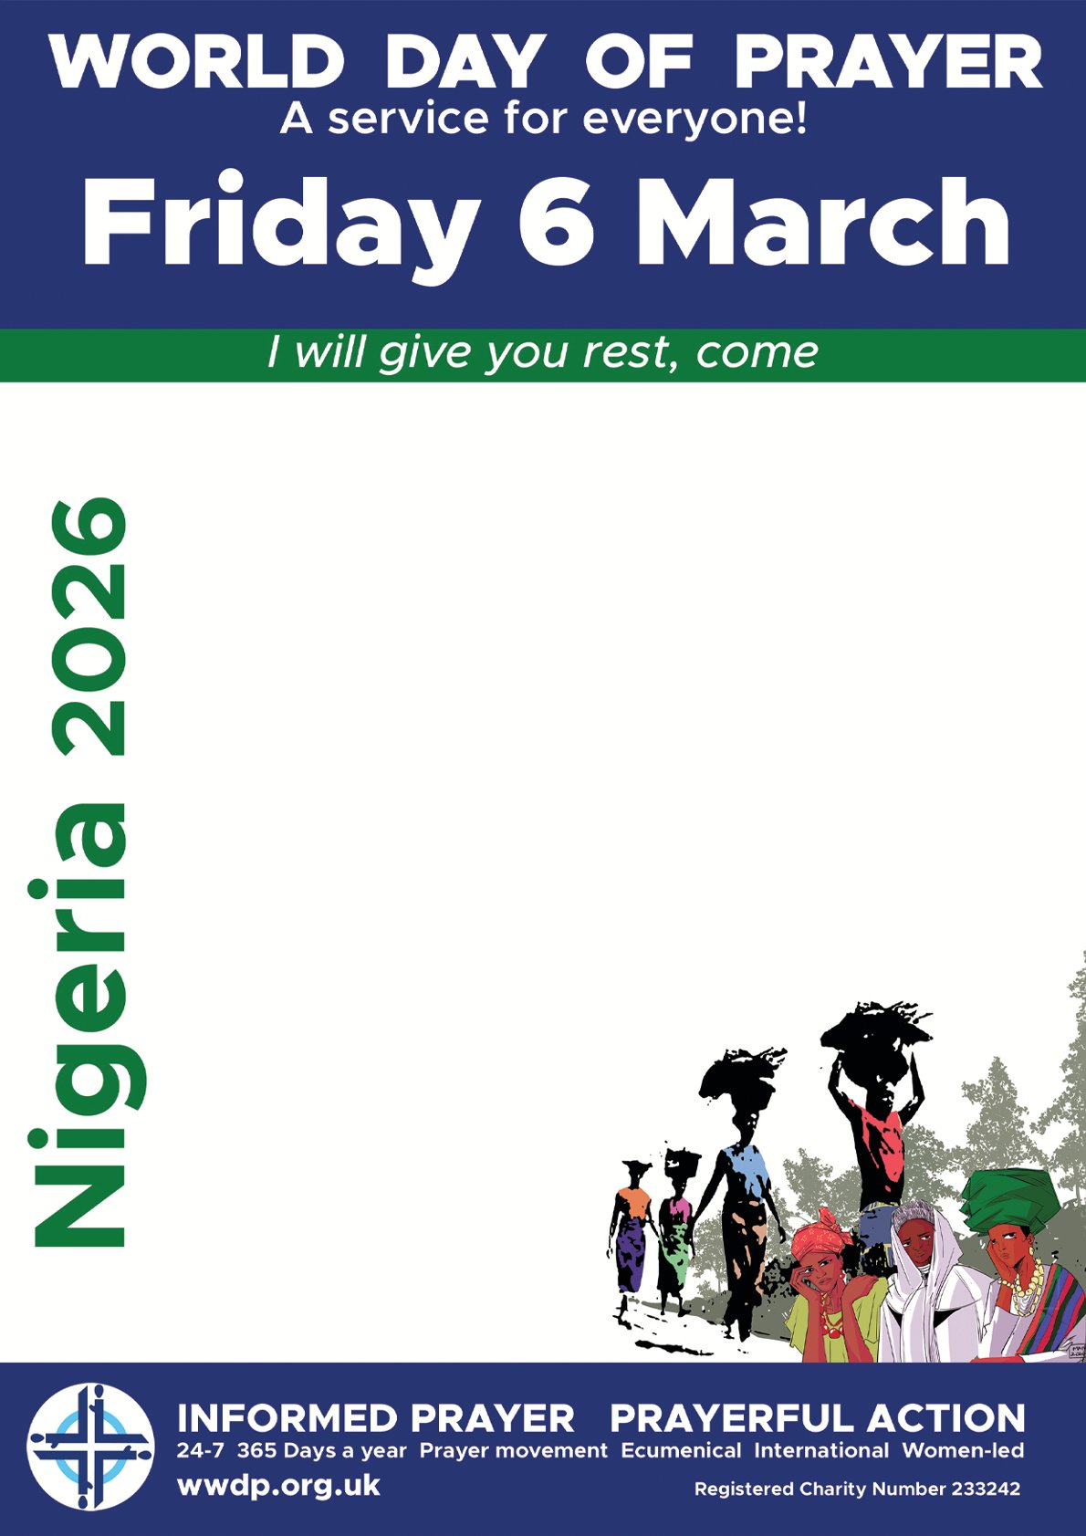
Hadleigh
United Reformed Church
Church Road
2pm
Light Refreshments
Afterwards

