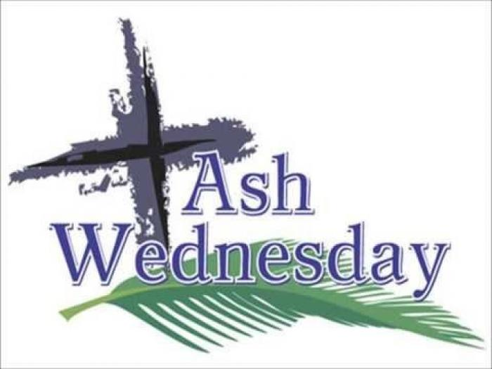
18th February

10am All Saints, Alrewas
(Holy Communion with imposition of ashes – a said Service)
7.30pm St Stephen’s, Fradley
(Holy Communion with hymns and music
and with imposition of ashes)

Do join us at either service!

