St Giles Horspath
Easter Vigil with bonfire and blessing of Easter Candles

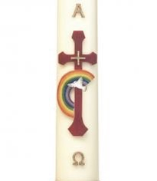

Holy Saturday 4th April at 7.30pm
Followed by toasted marshmallows on the bonfire


