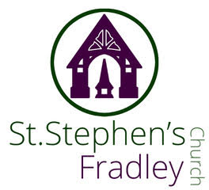
Heritage
Event

Thursday
19th March 7.30pm


“Nicely Matured Folk”
An informal concert of
traditional folk music from
around the British Isles

Come and enjoy hospitality whilst listening
to some good music.
Wine, soft drinks and savouries served
Free event

Donations invited for
CANCER UK and St Stephen’s Church

