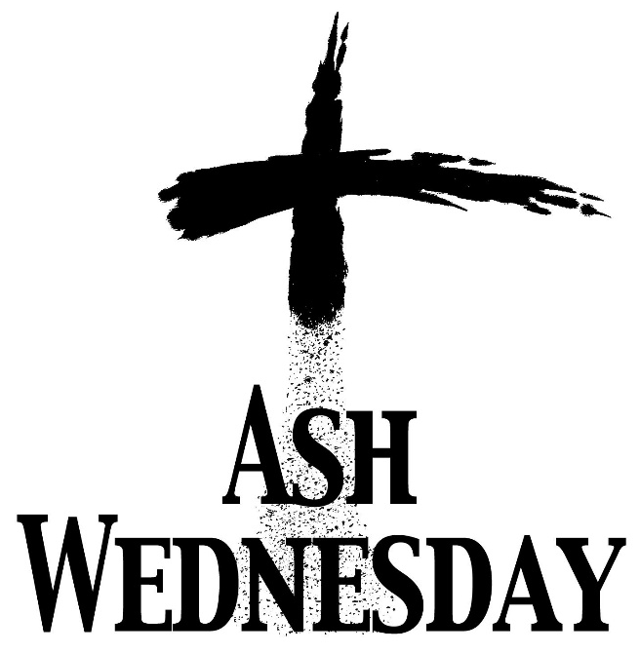

18th February 2026

Services of ashing and holy communion at

St Ann’s, Belfield 10.30 am

St Michael’s, Bamford 10.30 am

St Mary in the Baum 7.00 pm

All welcome

