Maundy Thursday 2nd April
Eucharist and Washing of Feet

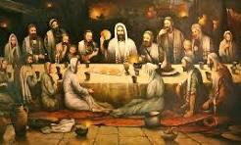
The Last Supper, 1998, by Polish artist Bohdan Piasecki

7.30pm at All Saints Cuddesdon
Everybody is welcome

