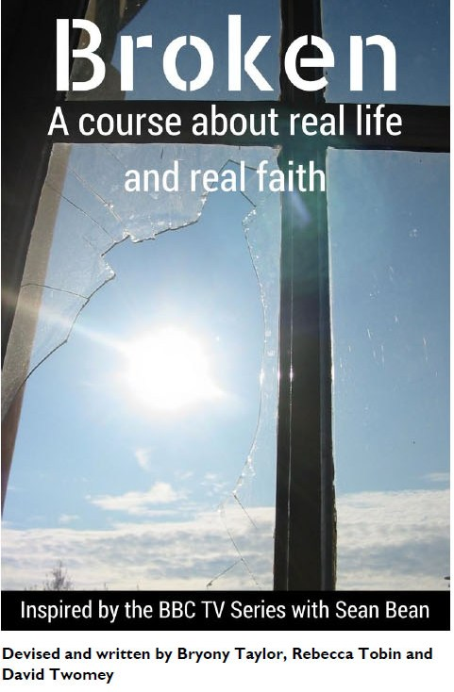
“Broken” is ultimately a drama about the seemingly insignificant ways we touch people’s lives, and the sins of omission that can loom so large. It homes in on how the most minute events can set off a cataclysm in someone else’s life, but also focuses on the equally small acts of kindness that can transform someone’s day. It is above all a celebration of community and the connections we should all try to find.
The course is in six parts:
• Beauty in the ordinary
• Loving the unlovable
• Guilt and shame
• Impossible situations
• The power of Holy Communion
• Is the church relevant and needed today?
We begin after church on Sunday, 22nd February with a simple lunch at 12:00.

