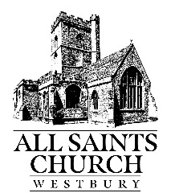
All Saints’ Church Westbury Organ Fund

If you would like to sponsor a particular hymn, please complete this form together with your donation of £10 which will go straight to the All Saints’ Church Organ Fund.
We will do our best to indicate the approximate time that Ian will play your choice so you can be there.

Your name:

Contact email / phone number:

Name of the hymn / first line:

