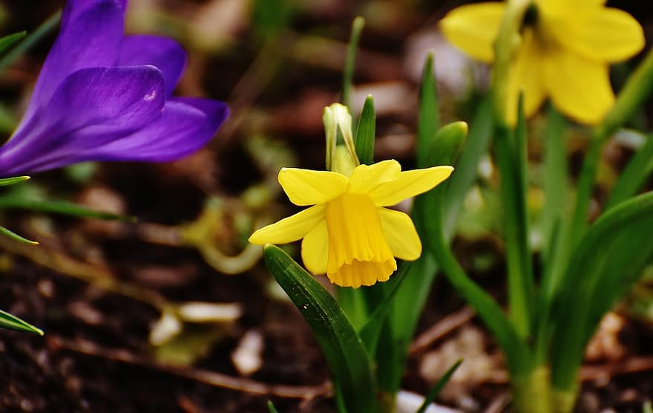
St Oswin’s Church
15 February
4pm
Music for Springtime: ‘enfolded in love’
Music by James Hawks (Organ)
Come and bring a friend

