
Your Bible is not just for Sunday
New Beginnings
Sunday    Genesis 8:18  They all came out of the ark. | Monday  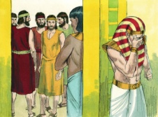  Genesis 42  Joseph and his family reunited | Tuesday  J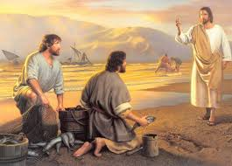  Matthew 3:18-22  Jesus calls  Simon & Andrew | Wednesday  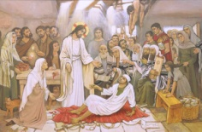  Luke 5:17-26  Take up your mat and go home. | Thursday    John 11:38-43  Lazarus, come out! | Friday    TH  Acts 2:1-13  The Holy Spirit  Comes at Pentecost | Saturday    Revelation 21:1-5  See, I am Making All Things New
Every day is a Bible day
Spend time each day with God.

