
Worship at
St Botolph’s (Heene)

Sunday February 1st
4.00pm
A time of reflection
in the style of Taizé
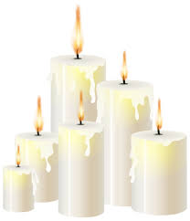
Come and share
in the simplicity of candle-lit
prayer and praise

