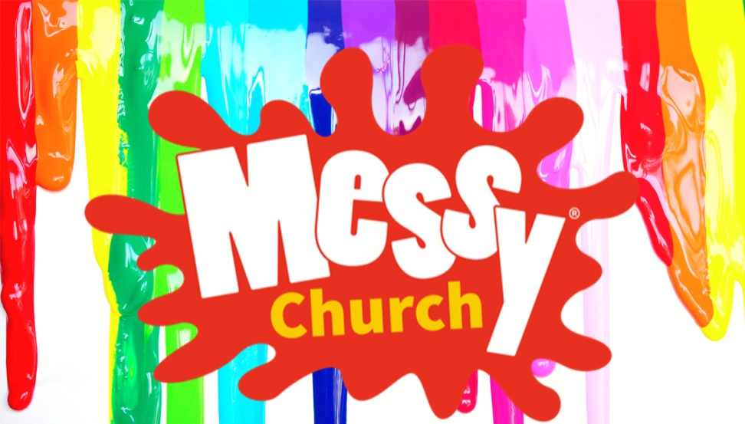
Come and join us for
New Beginnings





Sunday 25 January
3:30pm – 5:00pm
in The Vicarage School Room,
Queen Street, Gillingham
(the old building opposite St Mary’s Church)
Informal worship, craft activities and tea.



We hope to see you there


