The Great Gale Service
Sunday 8th February 10.30am
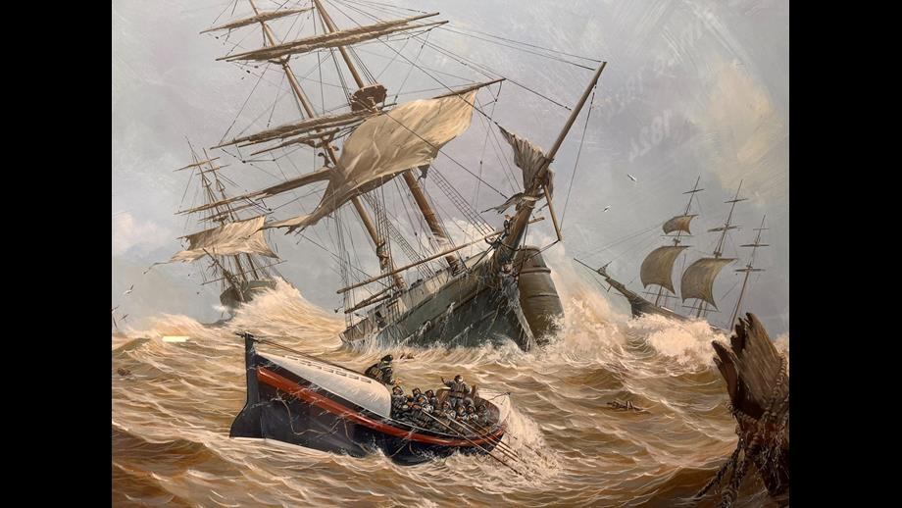
Picture by Mike Milner of the painting depicting The Great Gale Disaster of 1871, by artist Don Micklethwaite on display at Bridlington Lifeboat Station
A service with our RNLI, Coastguard, members of our harbour & fishing communities and others from Bridlington, to remember The Great Gale of 1871. We will also be giving thanks for all who risk their lives to save and protect others at sea and along our coastline.
All are welcome.

