Christmas Services
in the Carr DykE Group of Churches.

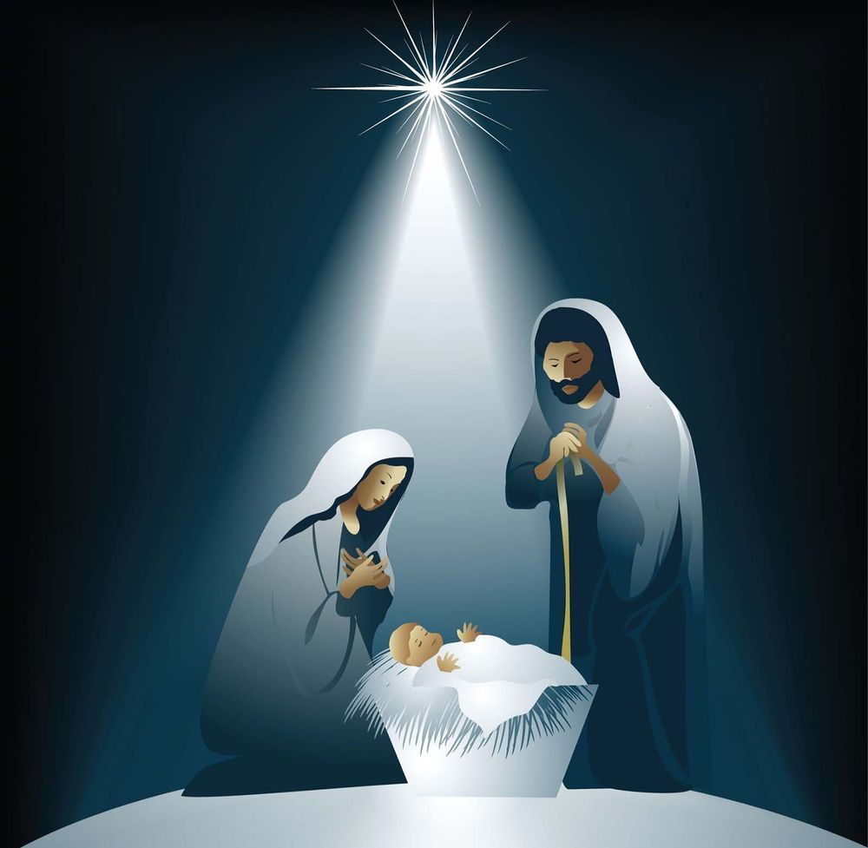

Sunday  14th December | 4.00pm | Billinghay | Carol service with the Methodist Chapel
Friday  19th December | 7.00pm | Walcott | Carol Service
Friday  19th December | 6.30pm | Martin | Carol Concert
Sunday  21st December | 3.00pm | South Kyme | Carol Service
Wednesday 24th December | 4.00pm | Timberland | Crib Service
Wednesday 24th December | 11.30pm | Billinghay | Midnight Communion
Thursday  25th December | 10.00am | Billinghay | Christmas Day Service

