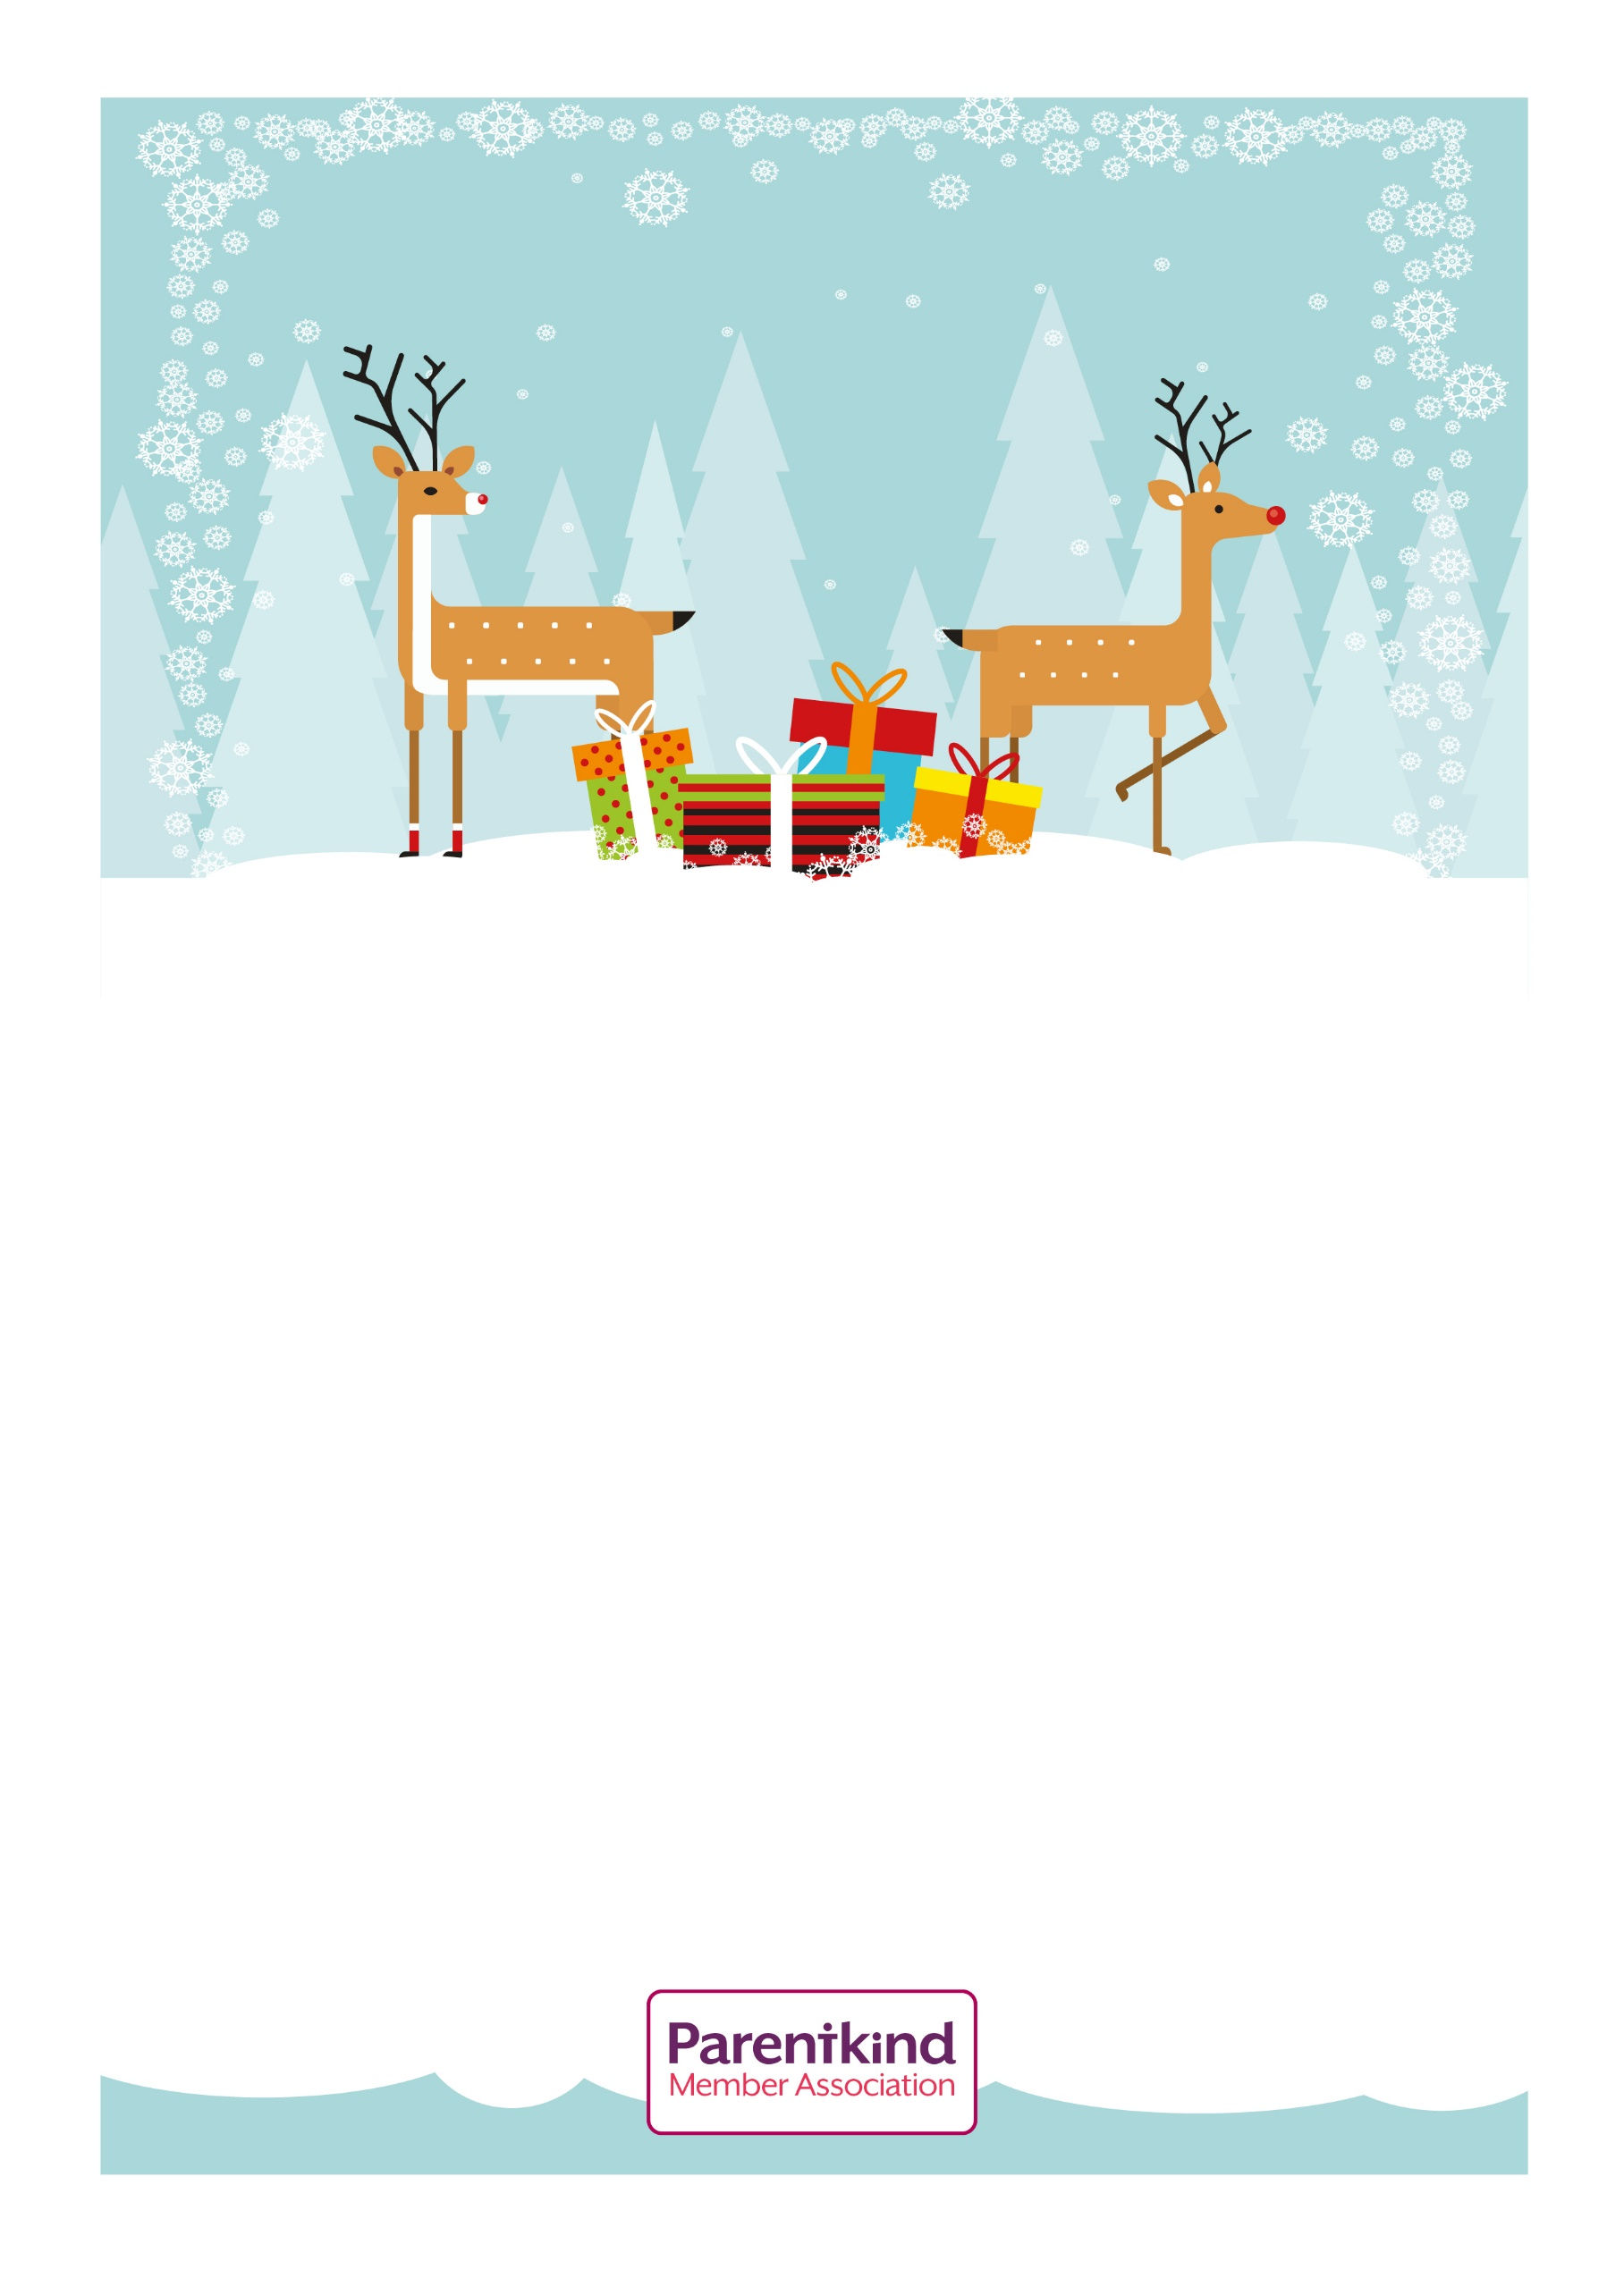
St. Michael’s Church
Pen Selwood


Service of Readings, Carols and a nativity by the children.

Bring a torch to add to the atmosphere of the candlelit service.

Please stay on for mulled wine and mince pies after the service in the Church

Sunday 14th December at 4.30pm
CAROL SERVICE
ALL WELCOME
Any children who would like to take part in the nativity should contact
Sarah Fitzgerald on 01747 840895

