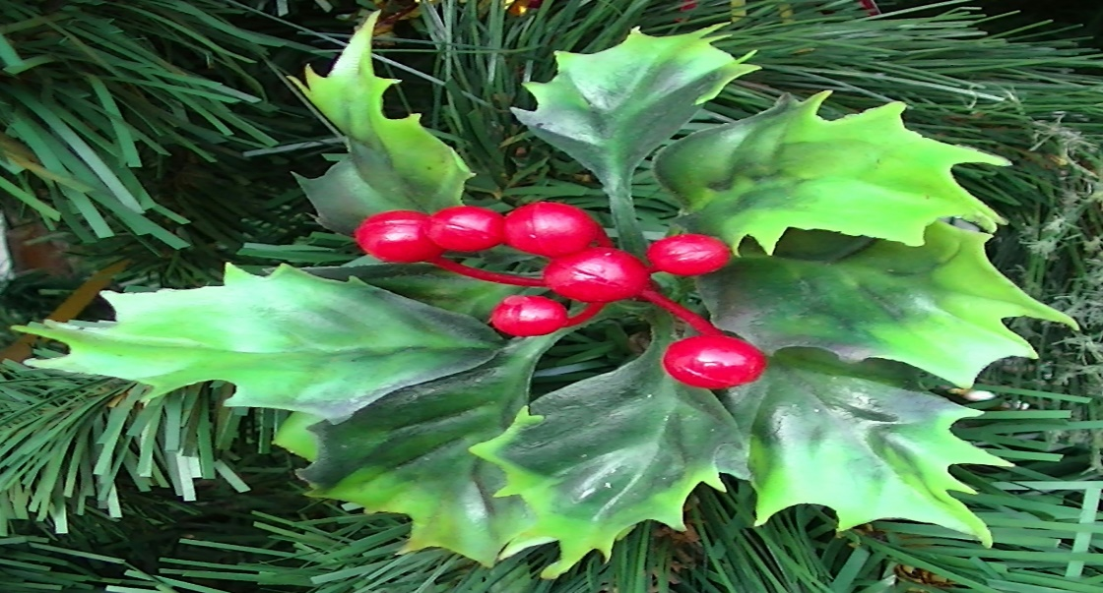
St. Hermes Church – St. Erme
Upper Fal Parishes
Service times over the Christmas period 2025.

24th December, Christmas Eve
There will be no service here but there will be Midnight Mass at 11.30 pm at Ladock and Probus churches.
There are also services at St. Nunn’s at Grampound at 9.00 pm and Tresillian at 8.00 pm

25th December, Christmas Day
Family Communion at 9.30 am with Rev Caroline

Sunday 28th December there is one service in the Benefice.
This is at Ladock Parish Church at 10.00 am and will be with Rev Pat Robson.

