
CHRISTMAS AT ST WILFRIDS, OTTRINGHAM
Come and join us for our festivities this year, we have something for everybody, just bring your festive cheer and singing voices!
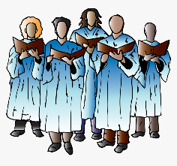Friday 12th December, 7pm, 9 Lessons and Carols (featuring the Deanery Choir). Service will be followed by mince pies and mulled wine.
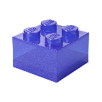Saturday 13th December, 9.30am-11am – Lego Church – free breakfast followed by a short story then build your bible story in Lego! It’s not just for kids but for adults too! Keep an eye out in the New Year for a new day and time!

Sunday 21st December, 11am, Holy Communion with Revd. Simon Clark (followed by refreshments)
Sunday 21st December, 3pm – come along and make your own Christingle (you are never too old to make your own Christingle), followed by a short service at 4pm, refreshments will be served afterwards.

Wednesday 24th December, 11pm – Midnight Mass (Holy Communion service) (service will last approx. 1 hour) led by Revd. Simon Clark

A perfect way to start your Christmas! We hope to see you there.
We would like to wish you all a very blessed and Happy Christmas and a Peaceful New Year. Love from St Wilfrids Church XX


