St. Mary’s Christmas Services
Hebdon Bridge Road BD22 9QJ
Rev Denise Hayes Tel: 07736523168
Email: denise.hayes@leeds.anglican.org

Sunday 7th December 10am Advent Service

Sunday 14th December 10am Dressing Crib Service
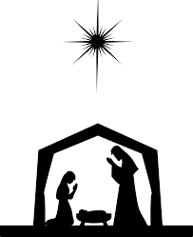

Friday 19th December 7pm Nativity at Old Oxenhope Farm – meeting at the Community Centre 6pm walking up to Goulding’s farm with Mary, Joseph & donkey
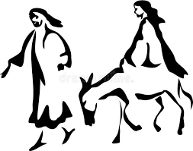
Sunday 21st December
10am Holy Communion & Baptism
6pm Nine Lessons and Carols

Christmas Eve
4pm Christingle Service
11.30pm Holy Communion
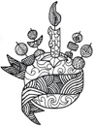
Christmas Day 10am Holy Communion

Young Farmers and St Mary’s
Nativity at Old Oxenhope Farm

Friday19th December meeting 6pm Community Centre
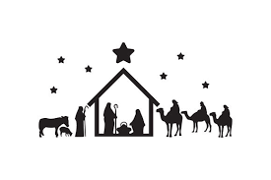
Come and join us as we bring the Nativity Story to life.
We are meeting at Oxenhope Community Centre 6pm on Friday 19th December, walking with Mary, Joseph and the donkey, singing carols to Goulding’s Farm, Old Oxenhope Road. Please bring lanterns with battery operated candles if possible.

At the farm, as we celebrate Jesus’ birth, we will be joined by Shepherds, sheep, alpaca’s and Wisemen.

After the Nativity you are warmly invited to stay to enjoy mulled wine, hot chocolate, cakes etc.

The event is free, any donations received towards refreshments the profit will be given to Winston’s Wish Charity.
Winston’s Wish support children through bereavement.

