St. Stephen’s Church
Fradley
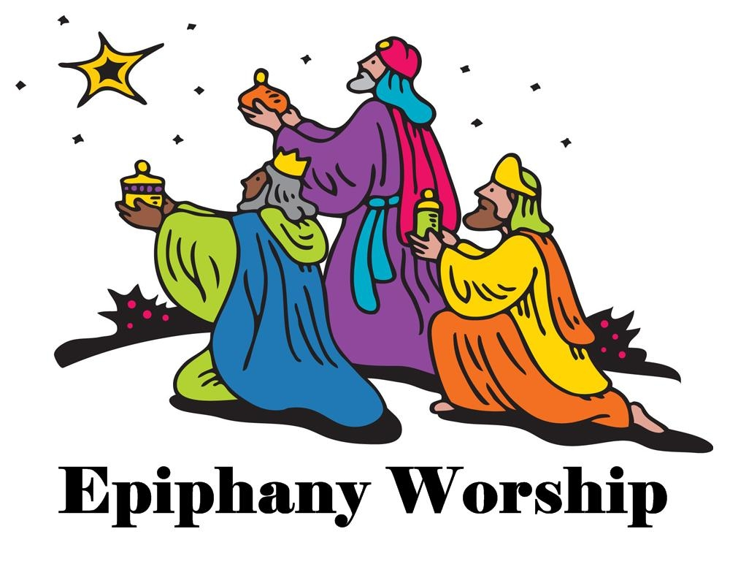
Sunday 4th January
10.30am Family Communion
for Epiphany

with
The Music Group

