
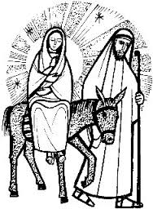
St. John the Divine, Sandylands
Christmas Services
Sunday 7th December - 4:00 p.m. Christingle Service

Thursday 18th December – 6:30p.m. Traditional Carol Service
in aid of St. John’s Hospice and St. John’s Church

Sunday 21st December - 10:30 a.m. Junior Church Nativity
4:00 p.m. Nine Lessons & Carols

Wednesday 24th December - 9:00 p.m. ‘Midnight Mass’

Thursday 25th December - 10:00 a.m. Holy Communion

