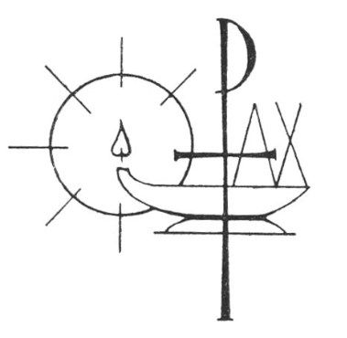Compline
An Order for Night Prayer Online for Advent

Preparation
The Lord almighty grant us a quiet night and a perfect end.
All Amen.
Our help is in the name of the Lord
All who made heaven and earth.

A period of silence for reflection on the past day may follow.

All Most merciful God, we confess to you,
before the whole company of heaven and one another, that we have sinned in thought, word and deed and in what we have failed to do.
Forgive us our sins, heal us by your Spirit
and raise us to new life in Christ. Amen.

O God, make speed to save us.
All O Lord, make haste to help us.
All Glory to the Father and to the Son
and to the Holy Spirit;
as it was in the beginning is now
and shall be for ever. Amen.
Alleluia.

Compline Hymn may be sung or said
Before the ending of the day,
Creator of the world, we pray
That you, with steadfast love, would keep
Your watch around us while we sleep.
From evil dreams defend our sight,
From fears and terrors of the night;
Tread underfoot our deadly foe
That we no sinful thought may know.
O Father, that we ask be done
Through Jesus Christ, your only Son;
And Holy Spirit, by whose breath
Our souls are raised to life from death.

The Word of God
Psalmody

Psalm 4
1 Answer me when I call, O God of my righteousness; *
you set me at liberty when I was in trouble;
have mercy on me and hear my prayer.

2 How long will you nobles dishonour my glory; *
how long will you love vain things and seek after falsehood?

3 But know that the Lord has shown me his marvellous kindness; *
when I call upon the Lord, he will hear me.

4 Stand in awe, and sin not; *
commune with your own heart upon your bed, and be still.

5 Offer the sacrifices of righteousness *
and put your trust in the Lord.

6 There are many that say, ‘Who will show us any good?’ *
Lord, lift up the light of your countenance upon us.

7 You have put gladness in my heart, *
more than when their corn and wine and oil increase.

8 In peace I will lie down and sleep, *
for it is you Lord, only, who make me dwell in safety.

At the end of the psalmody, the following is
said or sung
Glory to the Father and to the Son
and to the Holy Spirit;
as it was in the beginning is now
and shall be for ever. Amen.

Scripture Reading

Responsory
Into your hands, O Lord, I commend my spirit.
All Into your hands, O Lord, I commend my spirit.
For you have redeemed me, Lord God of truth.
All I commend my spirit.
Glory to the Father, and to the Son, and to the Holy Spirit.
All Into your hands, O Lord, I commend my spirit.

Keep me as the apple of your eye.
All Hide me under the shadow of your wings.

Gospel Canticle

Nunc dimittis (The Song of Simeon) is said or sung

All Save us, O Lord, while waking,
and guard us while sleeping,
that awake we may watch with Christ
and asleep may rest in peace.
1 Now, Lord, you let your servant go in peace:
your word has been fulfilled.
2 My own eyes have seen the salvation
which you have prepared in the sight of every people;
3 A light to reveal you to the nations
and the glory of your people Israel.
Luke 2.29-32
Glory to the Father and to the Son
and to the Holy Spirit;
as it was in the beginning is now
and shall be for ever. Amen.

All Save us, O Lord, while waking,
and guard us while sleeping,
that awake we may watch with Christ
and asleep may rest in peace.

Prayers

Intercessions and thanksgivings may be offered here.

The Collect

Visit, Lord, we pray, this place,
and drive far from it all the snares of evil.
Let your holy angels dwell here to keep us in peace, and may your blessing be upon us evermore; through Jesus Christ our Lord. Amen.

The Conclusion

In peace we will lie down and sleep;
All for you alone, Lord, make us dwell in safety.
Abide with us, Lord Jesus,
All for the night is at hand and the day is now past.
As the night watch looks for the morning,
All so do we look for you, O Christ.

The Lord bless us and watch over us;
the Lord make his face shine upon us and be gracious to us;
the Lord look kindly on us and give us peace.
All Amen.



Copyright acknowledgment (where not already indicated above):

Luke 5.1-11: © 1989 National Council of the Churches of Christ, USA
Wilfrid of Ripon (C): © Diocese of Chichester
Nunc dimittis (Night Prayer): © English Language Liturgical Commission
Some material included in this service is copyright: © The Archbishops' Council 2000

