CANDLELIGHT SERVICE
OF
NINE LESSONS &CAROLS
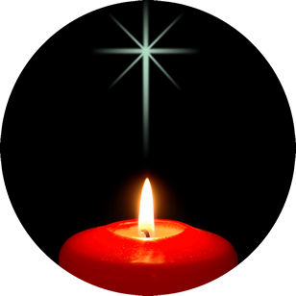

SUNDAY 21 DECEMBER
ALL SAINTS CHURCH
7.00pm
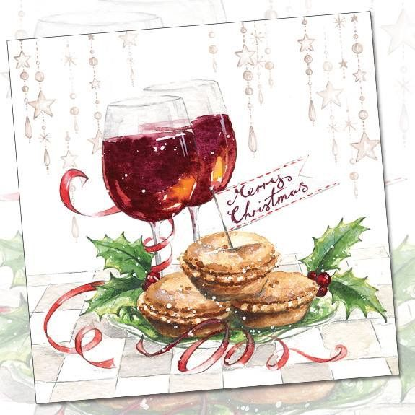
followed by mince pies and mulled wine

5.00pm
mince pies and mulled wine
Served from All Saints Church as you wait for the
6.00pm
TRACTOR RUN

