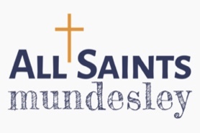
CHRISTMAS DAY LUNCH - BOOKING FORM
Christmas lunch in ALL SAINTS MUNDESLEY

The Community Hub is hosting Christmas Dinner for all who would otherwise be alone and would like to celebrate with us.

Join us CHRISTMAS DAY at 12 noon for a full 3 course lunch

ENJOY our hospitality with good company for all.

BOOKING ESSENTIAL

Please complete form and return no later than 18th December 2025

Let us know of any special dietary requirements in the space below and we will be happy to provide delicious alternatives.

Name

Address

Telephone

Any transport required

Special dietary needs

Ages of children under 18

