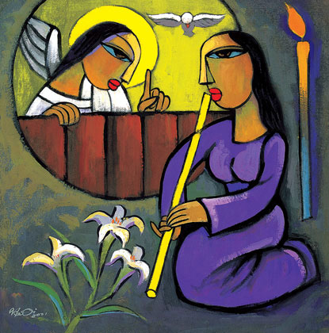
Pregnant with Hope
(Reflections for Advent)

Join us for an evening of reflections for Advent, along with poetry and music. The evening will be led by Professor Tina Beattie.

Tina is Professor Emerita of Catholic Studies at the University of Roehampton in London and a well-known Roman Catholic theologian. She has published extensively on sacramentality, desire, embodiment and gender, engaging with psychoanalytical theory and art history as well as theology. She has a particular interest in Marian theology, art and devotion. She now works as an independent researcher and writer. In addition to her academic publications, Tina is also a published novelist and a regular contributor to the media, including BBC Radio 4’s “Thought for the Day”.

Please join us for what will undoubtedly be an interesting, thought-provoking and stimulating evening.

Date: Wednesday December 10th, 2025

Time: 7.00 pm

Venue: St Thomas the Apostle Church, Camber, New Lydd Rd, TN31 7RJ

Wine and cheese will be served after the talk.

There’s plenty of parking in both the church grounds and the neighbouring street.
For more details, please contact The Revd. Jacques Desrosiers, on 07931 217458 (including WhatsApp) or email jtmdesrosiers@gmail.com.

