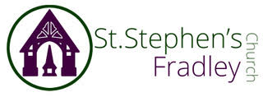

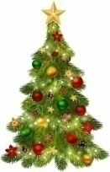
Christmas Tree Festival
20th-29th December
Free Entry

Refreshments available on
Saturday 20th December
10am-12 noon
Grand Hamper Raffle Draw at 12noon
Coffee, Cakes, Mince Pies
and Chocolate treats

